tasks for week - 1

Motioncut

The Week -1 comprised two tasks : one involving the development of a Simple Calculator and other one centered around creating a Number Guessing Game.

Name : Ganesh G

Internship : Java Internship (25 Sep 2023 – 25 Oct 2023)

Place : Bangalore

Phone : +91 8095912681

Email : ganeshg2k3@gmail.com

Contents

Task - 1 Simple Calculator

Task - 2 Number Guessing Game

# Task – 1 Simple Calculator

## introduction

I've developed a basic calculator using the Java programming language. This calculator takes two user-input numbers and performs fundamental arithmetic operations such as addition, subtraction, multiplication, and division. It delivers the appropriate result depending on the operation selected by the user.

## program

Here is a Java program for a simple calculator. I utilized the IntelliJ IDEA integrated development environment to write and compile this code.

import java.util.Scanner;  
  
public class Calculator {  
 public static void main(String[]args) {  
 Scanner scanner = new Scanner(System.*in*);  
 boolean exit = false; // Variable to control the loop  
  
 while (!exit) {  
 System.*out*.println(" Calculator:");  
 System.*out*.print("Enter the First number: ");  
 double num1 = scanner.nextDouble();  
  
 System.*out*.print("Enter the Second number: ");  
 double num2 = scanner.nextDouble();  
  
 System.*out*.println("Select an operation:");  
 System.*out*.println("1. Addition (+)");  
 System.*out*.println("2. Subtraction (-)");  
 System.*out*.println("3. Multiplication (*)");  
 System.*out*.println("4. Division (/)");  
  
 int choice = scanner.nextInt();  
  
 double result = 0;  
  
 switch (choice) {  
 case 1:  
 result = num1 + num2;  
 break;  
 case 2:  
 result = num1 - num2;  
 break;  
 case 3:  
 result = num1 * num2;  
 break;  
 case 4:  
 if (num2 != 0) {  
 result = num1 / num2;  
 } else {  
 System.*out*.println("Error: Division by zero");  
 return;  
 }  
 break;  
 default:  
 System.*out*.println("Invalid operation");  
 return;  
 }  
  
 System.*out*.println("Result: " + result);  
  
 // Ask the user if they want to perform another operation  
 System.*out*.print("Do you want to perform another operation? (yes/no): ");  
 String continueChoice = scanner.next().toLowerCase();  
 if (!continueChoice.equals("yes")) {  
 exit = true; // Exit the loop if the user doesn't want to continue  
 }  
 }  
  
 System.*out*.println("Calculator program has been terminated.");  
 }  
}

## Sample output

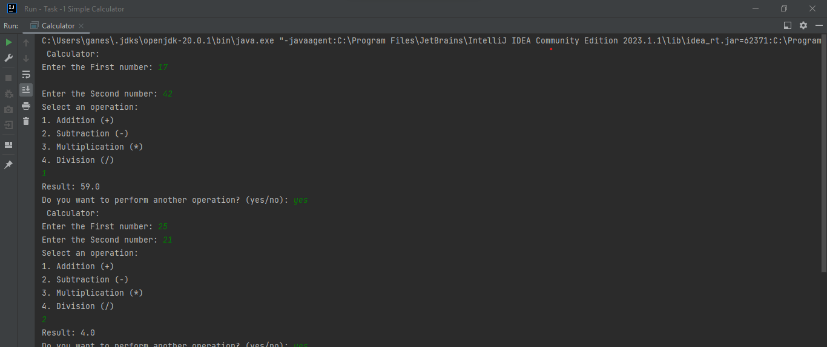Here is a sample output of the code.

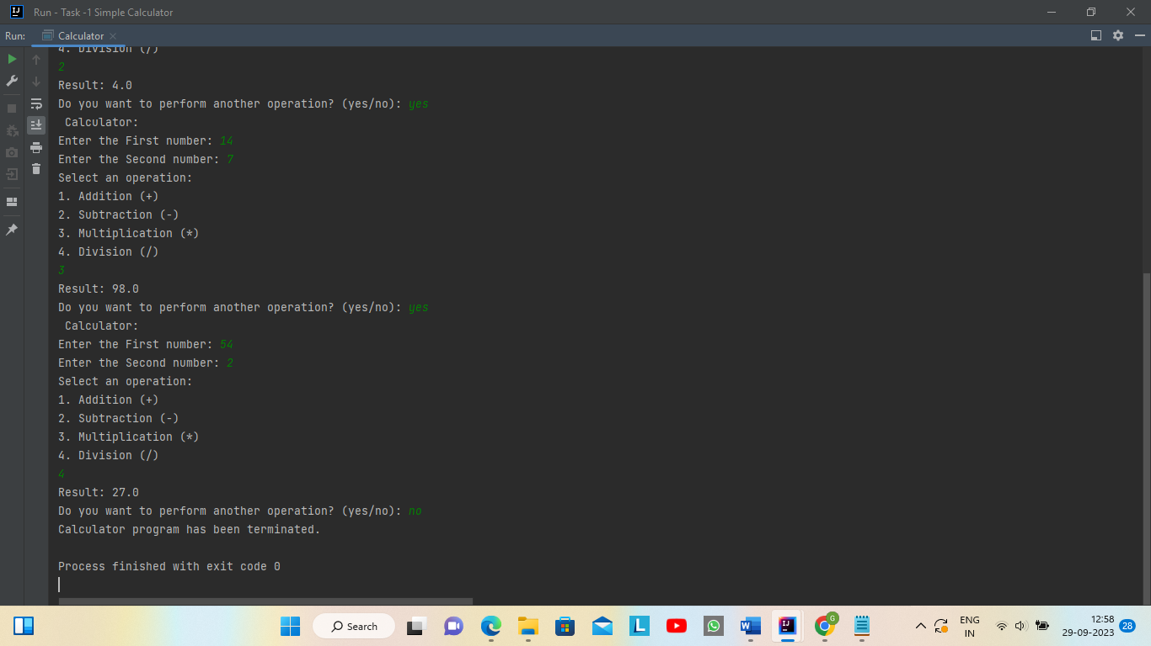

# Task – 2 Number Guessing Game

## introduction

I've created a basic number guessing game using Java. In this game, the computer selects a random number within a specified range (1 to 100). The user enters their guess, and the program offers feedback, indicating if the guess is too high, too low, or correct. Additionally, the program keeps count of the user's attempts and displays it when they correctly guess the number.

## PRogram

Here is a Java program for Number Guessing Game. I utilized the IntelliJ IDEA integrated development environment to write and compile this code.

import java.util.Random;  
import java.util.Scanner;  
  
public class NumberGuessingGame {  
 public static void main(String[] args) {  
 Scanner scanner = new Scanner(System.*in*);  
 Random random = new Random();  
  
 int lowerBound = 1; // Define your lower bound here  
 int upperBound = 100; // Define your upper bound here  
 int randomNumber = random.nextInt(upperBound - lowerBound + 1) + lowerBound;  
  
 int attempts = 0;  
 boolean hasGuessedCorrectly = false;  
  
 System.*out*.println("Number Guessing Game :");  
 System.*out*.println("I have chosen a random number between " + lowerBound + " and " + upperBound + ". Try to guess it!");  
  
 while (!hasGuessedCorrectly) {  
 System.*out*.print("Enter your guess: ");  
 int userGuess = scanner.nextInt();  
 attempts++;  
  
 if (userGuess < lowerBound || userGuess > upperBound) {  
 System.*out*.println("Please enter a number within the specified range.");  
 } else if (userGuess < randomNumber) {  
 System.*out*.println("The number is too low! Try again.");  
 } else if (userGuess > randomNumber) {  
 System.*out*.println("The number is too high! Try again.");  
 } else {  
 hasGuessedCorrectly = true;  
 System.*out*.println("Congratulations! You guessed the number " + randomNumber + " correctly in " + attempts + " attempts.");  
 }  
 }  
  
 scanner.close();  
 }  
}

## Sample Output

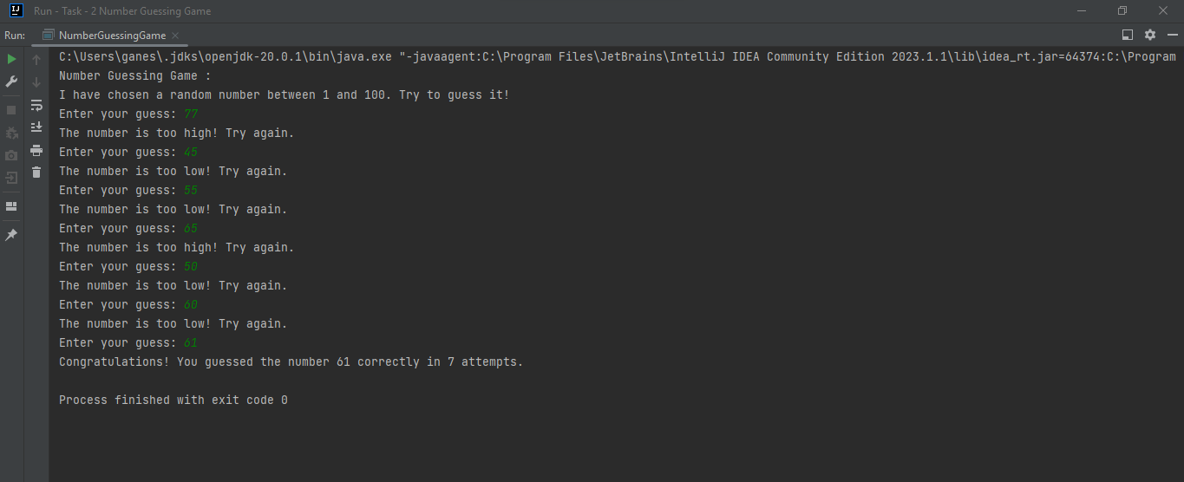

## Conclusion

During my first week of the internship, I did two tasks: I made a basic calculator and a guessing game with numbers. This helped me get better at programming and learn by doing. I'm looking forward to the next weeks, where I want to do more and keep learning while helping the team.